Module 2

Assignment 2.2
Course: CSD420-340A Advanced Java for Programmers
Prepared By: Mirach Erkol
Date of Report: 4/5/2026

https://github.com/Mikey5007/csd-420.git

2.2 Assignment: Successfully running the reader and writer programs to create and append the file.

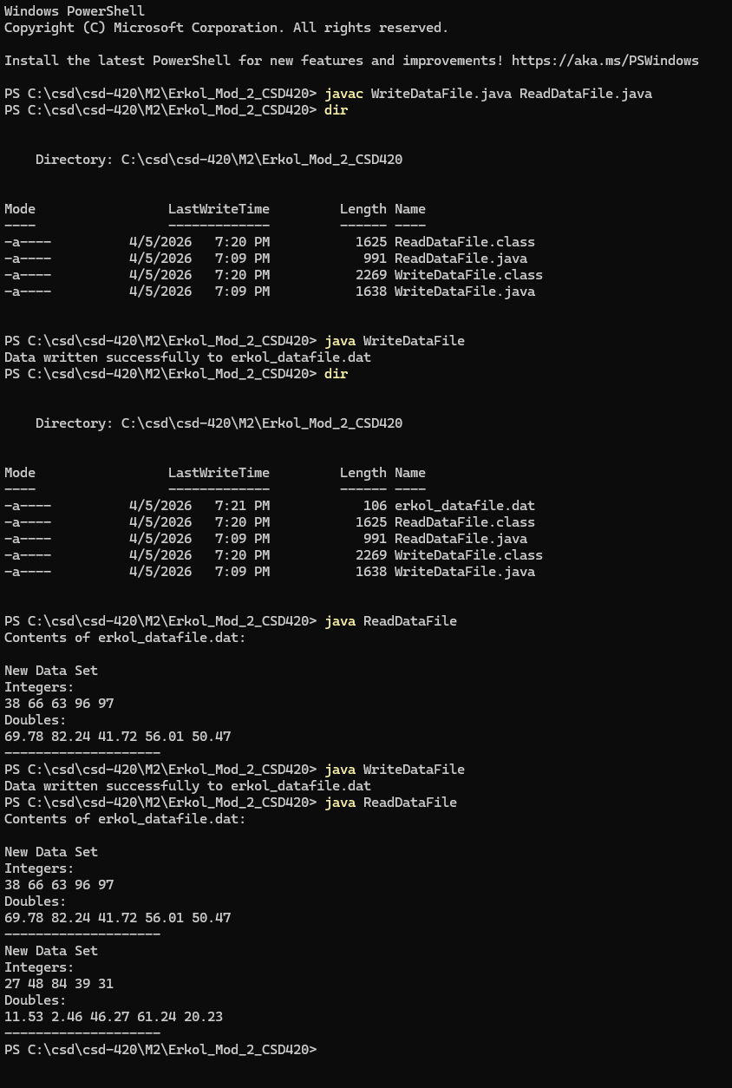

References:

https://github.com/Mikey5007/csd-420.git

